The 2002 National Electric Code (NEC)



As we begin our series of lessons, I remind you of the documents you need to make these lessons understandable. The references will be taken from the 2002 NEC. The other documents you need are the 1996, 1999 codebooks along with your notebook for critical information. Codebooks are available from your sign association, electrical supply store, Union, electrical inspector association, or direct from the National Fire Protection Association. I will travel through the document providing commentary and references to sections that have some impact on our industry. In your codebook you will notice a vertical line drawn in the margin left of sections which have been revised since the last code cycle. When you encounter these sections you may wish to review the old section to review the change. The reference articles will not be reprinted completely since you will need your codebook for reference. As I reference and comment on an article or section please read it in its entirety from your codebook and make notes if you have questions, concerns or comments. Your questions and comments can be e-mailed to me at randy@ussc.org. I would ask that you allow the questions to be published as a learning tool for those reading the column and doing the training. Your name and identity can be included or withheld at your option.

Lesson 1: Article 80-90 and Chapter 1 General

The 2002 National Electric Code (NEC) Lesson 1

ARTICLE 80: Administration and Enforcement
The code is for information only unless specifically adopted by the local jurisdiction.

80.1 Scope. The scope covers the functions of the code such as the inspection of electrical installations and the investigation of fires related to electrical installations.

80.2 Definitions. Authority Having Jurisdiction. (AHJ) The key wording is "responsible for approving" The terminology of approving is misused quite frequently in our industry.

You hear a lot of us saying "that is UL approved" when UL does not approve anything. They List, Recognize, or Classify products. Only an electrical inspector (AHJ) can approve an installation.

80.5 Adoption.

This means that the document is just a good reference unless your local jurisdiction has adopted it. Jurisdictions adopt the code by ordinance in different ways. Most building codes such as B.O.C.A., I.B.C., and soon to be completed the NFPA building have a reference in their codes referencing all electrical installations shall comply with NFPA 70, which is the National Electric Code. Some jurisdictions will adopt the code as it becomes effective, some will retain a previous version of the code and some will adopt and modify sections to meet their needs specifically. You will need to know what version and modifications, if applicable, are in effect in the areas where you work. This information can be obtained by calling the local code office. If the local jurisdiction has modified the code by ordinance you will need to obtain a copy of the changes.

ARTICLE 90 Introduction

90.1 Purpose. The purpose of the code is the safety of persons and property.

90.3 Code Arrangement.
This Code is divided into the introduction and nine chapters, as shown in Figure 90.3. Chapters 1, 2, 3, and 4 apply generally; Chapters 5, 6, and 7 apply to special occupancies, special equipment, or other special conditions. These latter chapters supplement or modify the general rules. Chapters 1 through 4 apply except as amended by Chapters 5, 6, and 7 for the particular conditions.
Chapter 8 covers communications systems and is not subject to the requirements of Chapters 1 through 7 except where the requirements are specifically referenced in Chapter 8.
Chapter 9 consists of tables.
Annexes are not part of the requirements of this Code but are included for informational purposes only.
See Figure 90.3 Code Arrangement. Located on page 70-30 in your 2002 codebook.

The importance of the arrangement for us is that we must initially comply with the first four chapters for our general wiring and that we may modify sections as provided in Article 600. We our identified as "Special Equipment" and allowed to modify the use of some equipment when used only in an electric sign application. An example is our ability to use 1/2" flexible metal conduit as a bonding means for secondary circuits in accumulative lengths up to 100 feet.
The arrangement of the code is very important for us to understand. We need the familiarization and ability to convey our points effectively and convincingly to the inspectors. In many jurisdictions, the inspectors have so much work to do with other electrical installations that signage becomes secondary. Sign inspection is usually a small cost center compared to the other installations they inspect. Sometimes their familiarization of our articles of the code can become a little rusty and they appreciate our assistance in most cases. Remember; be kind the electrical inspector still has the last word in their jurisdiction.

Chapter 1 General
ARTICLE 100 Definitions

The article contains definitions used for the proper application of the code. Many of these terms relate to signs and outline lighting. Terms such as accessible, bonding, electric sign and others have an impact on the enforcement of the code. Review the definitions and make sure you understand their meaning.

ARTICLE 110 Requirements for Electrical Installations

110.1 Scope.
This article covers general requirements for the examination and approval, installation and use, access to and spaces about electrical conductors and equipment, and tunnel installations.
This section upon adoption, gives the inspector the authority to accept or reject installations based on any of the above terminology. The "installation and use" means if they find products being used not in conformance with their installation instructions they can reject the installations. The "access to and spaces" can relate to the lighted walkway installed behind all of our installations in malls and shopping centers where we install and access the interior wiring.

110.2 Approval. This section relates to the conductors and equipment (Signs) that are required or permitted by the code shall only be acceptable if approved. This means it must be approved by the local authority having jurisdiction. (AHJ)

110.3 (B) Installation and Use. This section requires that equipment be installed and used in accordance with its installation instructions. All the products we use have installation instructions provided by their manufacturers, which require how the product is to be used and what restrictions are placed on its use.

“Conditions of Acceptability”

This section is one of the more frequently violated sections of the code.
I dwell at lot on "Conditions of Acceptability". The conditions of acceptability refer directly to how the product should perform under certain conditions and how it has been tested for Listing, Recognition or Classification. This means if you place a damp location product in a wet location you violate it conditions of acceptability. Examples: Placing a damp location rated boot or electrode enclosure in a wet location. If you install a component without using all of the parts; like only using one gasket on a metal clad (PK) housing. Not providing the additional grounding on a metal clad (PK) housing as required by their installation instructions. These installation infractions beyond violating the product's conditions of acceptability make you liable for its failure.

Lesson 1 Questions:

1. When does the NEC code become effective?
a. January 2002
b. Upon local or state adoption
c. July 2002

2. What is the purpose of the NEC Code?
a. The training of electrical inspectors.
b. As an instruction manual for electrical contractors.
c. The practical safeguarding of persons and property from hazards arising from the use of electricity.
d. All the above

- Why is the code arrangement important?
a. The chapters go from the easiest to the hardest.
b. Chapters 1-4 refer to general wiring and 5-8 supplements and modify the others for special conditions.
c. The chapters are arranged in the order of inspecting an electrical installation.
d. All the above

4. How does Article 110 Requirements for Electrical Installations relate to an electric sign installation?
a. Access to the electrical equipment (Signs).
b. Approval of conductors and equipment (Signs).
c. Require installation instructions for listed equipment (Signs).
d. All the above.

Answers available at the end of the Lessons

The 2002 National Electric Code (NEC) Lesson 2

Chapter 2 Wiring and Protection
Article 210 Branch Circuits
210.2 Other Articles for Specific-Purpose Branch Circuits.
This section referred you to Table 210.2 where under Electric signs and outline lighting it directs you to 600.6 (which is wrong) it should be 600.5 This is the Branch circuit section of Article 600 that covers the specific product. Another area where Article 600 modifies and supplements the general sections.

ARTICLE 225 Outside Branch Circuits and Feeders

225.1 Scope.

225.2 Other Articles. Table 225.2.
This article covers requirements for outside branch circuits and feeders. The key portion of this article refers to electric equipment and wiring for the supply of utilization equipment (electric signs) that is located on or attached to the outside of buildings, structures, or poles. The article refers to the primary wiring only to supply our signs. Since Signs are utilization equipment we will be referred to it in the table and directed to Article 600 for the specific branch circuit requirements.

ARTICLE 240 Overcurrent Protection

240.3 Other Articles. Table 240.3

This article refers you to Article 600 for specific overcurrent requirements. These requirements will modify this section and allow 30 ampere loads on neon tubing circuits. Remember when doing your primary wiring always use the correct AWG wire size that corresponds with your load and overcurrent protection.

ARTICLE 250 Grounding
I. General 250.1 Scope.
This article will outline the grounding and bonding requirements, which is one of the more prevalent problems in neon sign installations. The number one cause of neon sign fires that I deal with is lack of or inadequate Grounding/Bonding! (See my separate article on Grounding/Bonding)

250.2 Definitions.
Effective Ground-Fault Current Path. "….from the point of a ground fault on a wiring system to the electrical supply source."

Ground Fault. An unintentional, electrically conducting connection between an ungrounded conductor of an electrical circuit and the normally non–current carrying conductors, metallic enclosures, metallic raceways, metallic equipment, or earth.

Ground-Fault Current Path. An electrically conductive path from the point of a ground fault on a wiring system through normally non–current carrying conductors, equipment, or the earth to the electrical supply source.

I left most of the code language above because it is so very important. This defines some very important terms such as the effective current path. In our high voltage installations it is very important that all dead metal is bonded properly and returns the stray unwanted voltage back to the building wiring ground termination at earth ground and not allowed to run rampant in and around combustibles. Having this path interrupted will cause the fault current to seek a connection and arc tracking can occur.

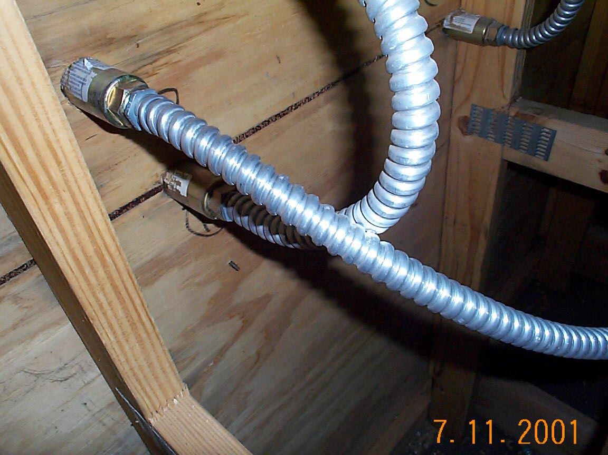
Note the electrical activity on the two conduits, grounding/bonding trying to make a path.

250.3 Application of Other Articles.

…requirements are identified in Table 250.3 that are in addition to, or modifications of, those of this article.
Refer to Article 600 for specific requirements.

250.4 General Requirements for Grounding and Bonding.

The following general requirements identify what grounding and bonding of electrical systems are required to accomplish. The prescriptive methods contained in Article 250 shall be followed to comply with the performance requirements of this section.
The key statement is what the bonding is required to accomplish and the prescriptive methods contained in the article. Lets review some of the methods required.

(3) Bonding of Electrical Equipment. Non–current-carrying conductive materials enclosing electrical conductors or equipment, or forming part of such equipment, shall be connected together and to the electrical supply source in a manner that establishes an effective ground-fault current path.

Effective ground-fault path means connectors can't be the wrong type or missing altogether, connections which are loose or where paint restricts the connection and where the path is not complete.

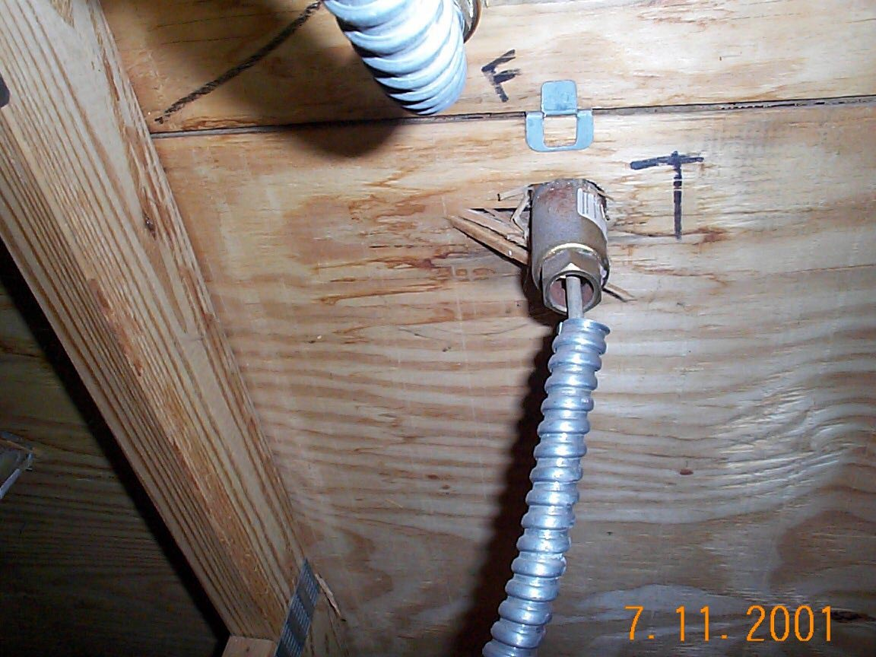
Double trouble:
- No means to connect the letter on the other end of the receptacle.
- Fault path broken without an approved connector.

250.8 Connection of Grounding and Bonding Equipment.
Grounding conductors and bonding jumpers shall be connected by exothermic welding, listed pressure connectors, listed clamps, or other listed means. Connection devices or fittings that depend solely on solder shall not be used. Sheet metal screws shall not be used to connect grounding conductors to enclosures.

250.12 Clean Surfaces.
Nonconductive coatings (such as paint, lacquer, and enamel) on equipment to be grounded shall be removed from threads and other contact surfaces to ensure good electrical continuity or be connected by means of fittings designed so as to make such removal unnecessary.

I reprinted the complete code sections here because it outlines the actual connection methods and procedures. This is very important in our industry since we find a lot of metal clad receptacles (PK Housings) depending on the compression of the glass insert and removal of the rear gasket. This violates the manufacturers installation instructions and omission of adequate continuous grounding/bonding is the cause of a number of fires. Simply bonding the letters and the receptacle shells back to the building wiring system would have prevented these problems.

V. Bonding
250.90 General.

Bonding shall be provided where necessary to ensure electrical continuity and the capacity to conduct safely any fault current likely to be imposed.

250.96 Bonding Other Enclosures.

(A) General. Metal raceways, cable trays, cable armor, cable sheath, enclosures, frames, fittings, and other metal non–current carrying parts that are to serve as grounding conductors, with or without the use of supplementary equipment grounding conductors, shall be effectively bonded where necessary to ensure electrical continuity and the capacity to conduct safely any fault current likely to be imposed on them. Any nonconductive paint, enamel, or similar coating shall be removed at threads, contact points, and contact surfaces or be connected by means of fittings designed so as to make such removal unnecessary.

Conduct safely any fault current means when a piece of neon goes out or a GTO wire burns fast inside a metal conduit the arc-fault return path will be complete and not create an arc track on combustibles in an attempt to complete the missing path. This section clarifies a couple common problems with some of the existing components used in our industry.

This clarifies metal non-current carrying parts need to provide the path with or without and alternate method provided such as a connection or devise provided as part, of the part. It also clarifies that paint needs to be removed or fittings need to be used which make removal unnecessary.

250.112 Fastened in Place or Connected by Permanent Wiring Methods (Fixed) — Specific.
(G) Electric Signs. Electric signs, outline lighting, and associated equipment as provided in Article 600.

This section reinforces the authority to bond all exposed non-current carrying metal parts.

250.119 Identification of Equipment Grounding Conductors.

This section provides the identification of the bonding conductors.

250.120 Equipment Grounding Conductor Installation.
Article 600 will supplement or modify some of these sections on size and protection of the bonding.

You should be as familiar with this section of the code as you are with Article 600.

Lesson 2 Questions:

1. Where is the information to size the primary branch circuits?
a. Article 210
b. Article 225
c. Article 600

2. What are considered suitable for grounding and bonding?
  - Listed pressure connectors
  - Sheet metal screws
  - Soldered connections
  - All the above

3. What colors are suitable for insulated bonding conductors?
a White
b White with green strip
c Green
d All the above

The 2002 National Electric Code (NEC) Lesson 3
Chapter 3 Wiring Methods and Materials

ARTICLE 300 Wiring Methods
I. General Requirements
300.1 Scope.
(A) All Wiring Installations. This article covers wiring methods for all wiring installations unless modified by other articles.
Chapter 3 is very important to understand, since all the wiring we do must conform to this chapter unless supplemented or modified by another chapter. We refer to Chapter 3 in Article 600 Part II as a reminder that the wiring methods in Part II must first confirm to Chapter 3 and then may be modified for special equipment.

300.3 Conductors

(C) Conductors of Different Systems

(2) Over 600 Volts, Nominal. Conductors of circuits rated over 600 volts, nominal, shall not occupy the same equipment wiring enclosure, cable, or raceway with conductors of circuits rated 600 volts, nominal, or less unless otherwise permitted in (a) through (e).
(a) Secondary wiring to electric-discharge lamps of 1000 volts or less, if insulated for the secondary voltage involved, shall be permitted to occupy the same luminaire (fixture), sign, or outline lighting enclosure as the branch-circuit conductors.
(b) Primary leads of electric-discharge lamp ballasts, insulated for the primary voltage of the ballast, where contained within the individual wiring enclosure, shall be permitted to occupy the same luminaire (fixture), sign, or outline lighting enclosure as the branch-circuit conductors.

This section permits the running of our primary and secondary in the same raceway provided we use the 1000-volt rated machine tool wire. The common use is for fluorescent and HID signs. For secondary conductors over 1000 volts (Neon) we must rely on using Listed enclosures suitable for the application. Refer to 600.5 (C) (2) Enclosures as Pull Boxes.

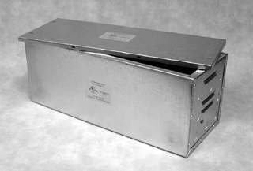
Listed Transformer Box
Photo compliments of Transco

300.10 Electrical Continuity of Metal Raceways and Enclosures.

This section clarifies continuity (BONDING) of all the raceway parts and transformer boxes. Transformers need to be bolted to their boxes to provide the correct bonding. Conduits, boxes, connectors, metal clad housings and all dead metal parts need to be bonded together and must be complete.

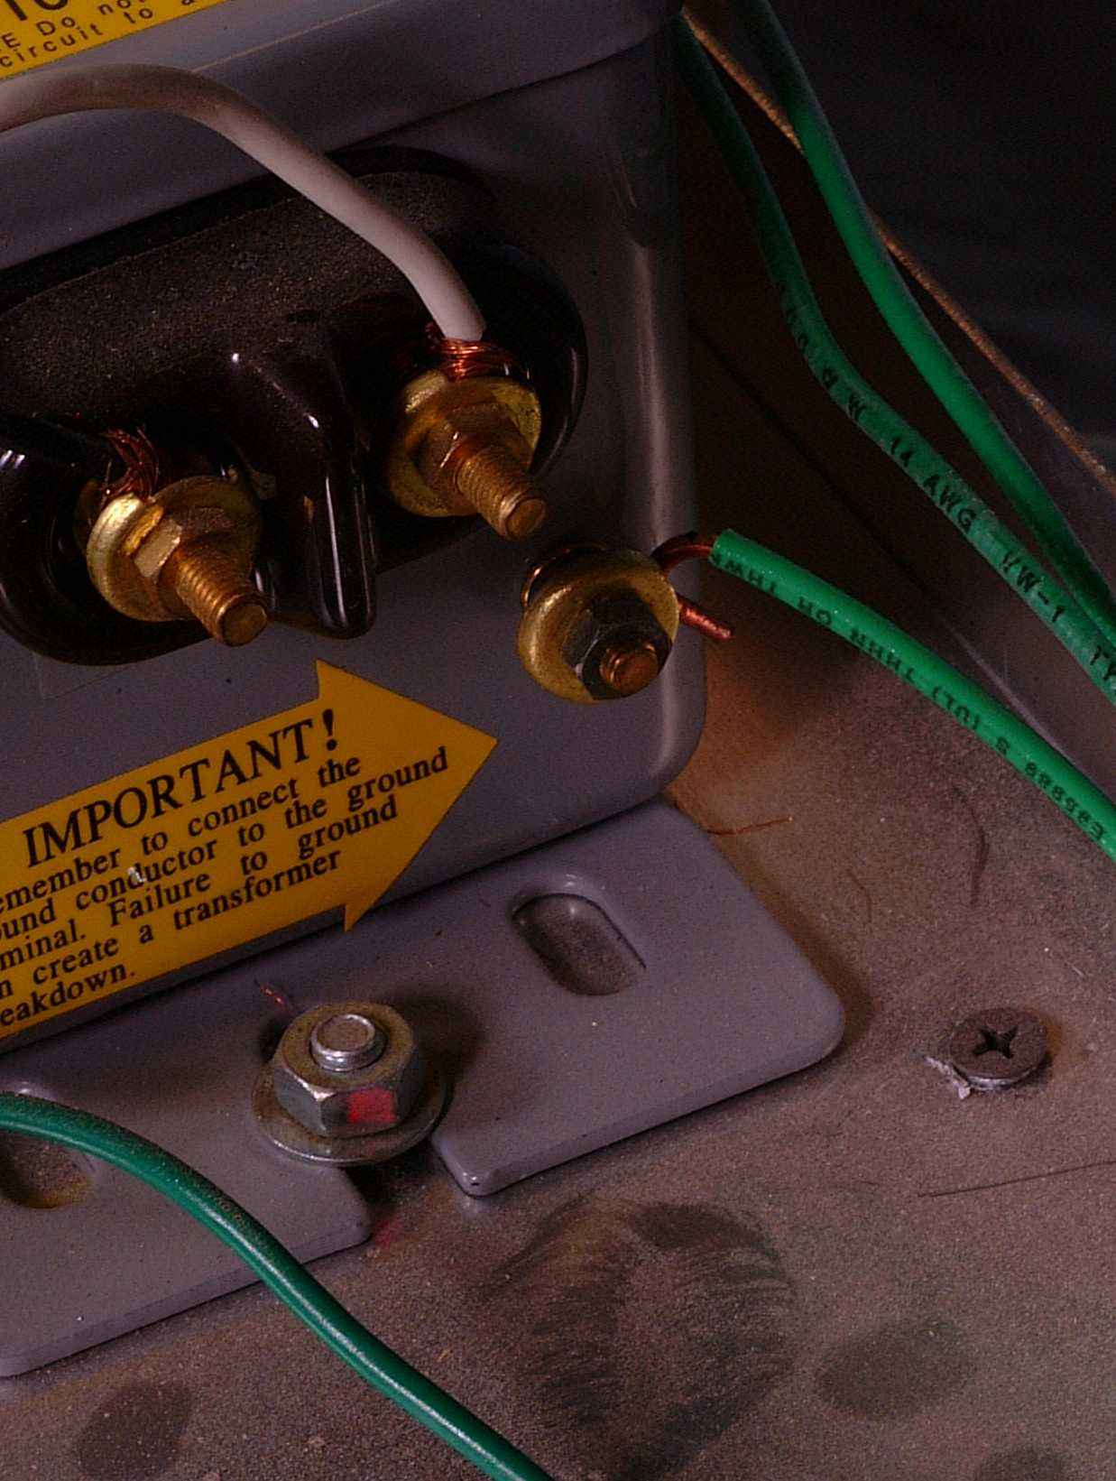
Additional bonding for transformer per manufacturers instructions

Transformer bolted to the enclosure
Photo compliments of NeonInstallationGuide
Bonding wires going to other parts of the system

300.17 Number and Size of Conductors in Raceway.
The number and size of conductors in any raceway shall not be more than will permit dissipation of the heat and ready installation or withdrawal of the conductors without damage to the conductors or to their insulation.
FPN: signs, 600.31(C);

This section references, allowed fill for all the different types of raceways. References are made to different sections of the code based on the raceway used. Check your codebook for the different sections.

ARTICLE 310 Conductors for General Wiring
310.1 Scope.
This article covers general requirements for conductors and their type designations, insulations, markings, mechanical strengths, ampacity ratings, and uses. These requirements do not apply to conductors that form an integral part of equipment, such as motors, motor controllers, and similar equipment, or to conductors specifically provided for elsewhere in this Code.

This section outlines the type and use of conductors. Example whether a wire can be used in a wet location, sunlight approved and the type of wire for special applications like the 1000-volt rated wire for fluorescent signs.

310.5 Minimum Size of Conductors.
The minimum size of conductors shall be as shown in Table 310.5.
Exception No. 10: For electric signs and outline lighting as permitted in 600.31(B) and 600.32(B).

This section outlines the minimum size requirements for conductor size and will reference Exception No. 10 for the use of #18 AWG GTO wire with an additional temperature rating of 105c for electric signs.

310.8 Locations.
- Dry Locations
- Dry and Damp locations
- Wet Location
- Locations Exposed to Direct Sunlight. Insulated conductors and cables used where exposed to direct rays of the sun shall be of a type listed for sunlight resistance or listed and marked “sunlight resistant.”
All conductors are not suitable for all locations.

310.11 Marking
- Required Information. All conductors and cables shall be marked to indicate the following information, using the applicable method described in 310.11(B):

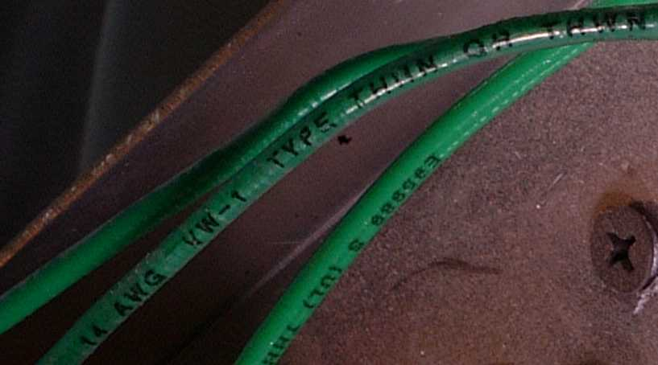
Conductors are marked with their rated voltage, type of wire, manufacturer, and AWG size.
Photo compliments NeonInstallationGuide

310.13 Conductor Constructions and Applications.

This section outlines the conductor applications and insulations in a series of tables.

Notably, GTO will not currently be found in this list.

Table 310.16 shows the allowable ampacities but note the asterisk referring 240.4(d)
This outlines the actual ampacities on our more commonly used wires.

310.60 Conductors Rated 2001 to 35,000 Volts.

Notably, GTO will not currently be found in this section either.

ARTICLE 314 Outlet, Device, Pull, and Junction Boxes; Conduit Bodies; Fittings; and Manholes

I. Scope and General

314.1 Scope.
This article covers the installation and use of all boxes and conduit bodies used as outlet, device, junction, or pull boxes, depending on their use, and manholes and other electric enclosures intended for personnel entry. Cast, sheet metal, nonmetallic, and other boxes such as FS, FD, and larger boxes are not classified as conduit bodies. This article also includes installation requirements for fittings used to join raceways and to connect raceways and cables to boxes and conduit bodies.

This article covers the use of the boxes and fitting we use in our installations. Note for example 314.5 Short-Radius Conduit Bodies reminds us we cannot splice in these types of bodies. Read each section carefully which relates to the parts you use in your installations.

II. Installation
314.15 Damp, Wet, or Hazardous (Classified) Locations.
(A) Damp or Wet Locations. In damp or wet locations, boxes, conduit bodies, and fittings shall be placed or equipped so as to prevent moisture from entering or accumulating within the box, conduit body, or fitting. Boxes, conduit bodies, and fittings installed in wet locations shall be listed for use in wet locations.

This section becomes important for sign section mounting and the entrance of water into the building wiring system. It also provides fill and volume calculations along with instructions on splices and taps.

314.16 Number of Conductors in Outlet, Device, and Junction Boxes, and Conduit Bodies.
- Box Volume Calculations.
- Box Fill Calculations
- Conduit Bodies
  - General
  - With Splices
This section provides information on the number of conductors allowed and provides table information to calculate volume and fill. The article further outlines the use of conduit bodies and when you can splice in a conduit body.

314.29 Boxes and Conduit Bodies to Be Accessible.
Boxes and conduit bodies shall be installed so that the wiring contained in them can be rendered accessible without removing any part of the building or, in underground circuits, without excavating sidewalks, paving, earth, or other substance that is to be used to establish the finished grade.

This section refers to the accessibility required with this equipment after installation.

Lesson 3 Questions

- Why is Chapter 3 important to the complete installation?
  - It outlines the wiring schematics
  - It outlines the wiring methods used in all wiring installations
  - It tells us how to bend conduit
  - All the above

- How does Chapter 3 deal with conductors?
  - Specifies the minimum size of conductors
  - Refers to other articles for modification.
  - Allows secondary and primary wiring in the same space
  - All the above

- Will GTO wire be found in this section?
  - Yes
  - No
  - When provided with sleeving

The 2002 National Electric Code (NEC) Lesson 4

ARTICLE 334 Nonmetallic-Sheathed Cable: Types NM, NMC, and NMS
I. General

334.1 Scope. This article covers the use, installation, and construction specifications of nonmetallic-sheathed cable.

Commonly referred to as “Romex”. This section will apply if you are using this type of cable for the primary connections. Be careful as to where and how you use it in commercial space.

ARTICLE 340 Underground Feeder and Branch-Circuit Cable: Type UF

I. General

340.1 Scope. This article covers the use, installation, and construction specifications for underground feeder and branch-circuit cable, Type UF.

Commonly referred to as “UF” cable. This section will apply if you are using this type of cable for the primary connections. Pay special attention to the uses permitted and not permitted before you install it.

ARTICLE 342 Intermediate Metal Conduit: Type IMC

I. General

342.1 Scope. This article covers the use, installation, and construction specifications for intermediate metal conduit (IMC) and associated fittings.

This section will apply if you are using this type of conduit, suitable in all locations and occupancies for the primary or secondary conductors. You must pay attention to fill, fastening and bend restrictions outlined in the article.

ARTICLE 344 Rigid Metal Conduit: Type RMC

I. General

344.1 Scope. This article covers the use, installation, and construction specifications for rigid metal conduit (RMC) and associated fittings.

This section will apply if you are using this type of conduit, suitable in all locations and occupancies for the primary or secondary conductors. You must pay attention to fill, fastening and bend restrictions outlined in the article.

ARTICLE 348 Flexible Metal Conduit: Type FMC
I. General
348.1 Scope. This article covers the use, installation, and construction specifications for flexible metal conduit (FMC) and associated fittings.

Commonly referred to as “Greenfield”. This section will apply if you are using this type of conduit, which is not suitable for wet locations for the primary or secondary conductors. You must pay attention to fill, fastening and bend restrictions outlined in the article. Article 348.20 allows a size reduction for 3/8” in restricted lengths and specific uses and will only apply to primary wiring under 1000 volts. Article 632 requires secondary conductors over 1000 volts will require a minimum of ½” trade size.

ARTICLE 350 Liquidtight Flexible Metal Conduit: Type LFMC
I. General
350.1 Scope. This article covers the use, installation, and construction specifications for liquidtight flexible metal conduit (LFMC) and associated fittings.

This section will apply if you are using this type of conduit, which is suitable for wet locations for the primary or secondary conductors. You must pay attention to fill, fastening and bend restrictions outlined in the article. Article 348.20 allows a size reduction for 3/8” in restricted lengths and specific uses and will only apply to primary wiring under 1000 volts. Article 632 requires secondary conductors over 1000 volts will require a minimum of ½” trade size.

ARTICLE 352 Rigid Nonmetallic Conduit: Type RNC
I. General
352.1 Scope. This article covers the use, installation, and construction specifications for rigid nonmetallic conduit (RNC) and associated fittings.

This section will apply if you are using this type of conduit, which is suitable for wet locations, review the Fine Print Note (FBN): concerning the application in cold temperatures for the primary or secondary conductors. You must pay attention to fill, fastening and bend restrictions outlined in the article. Article 600 has additional bonding spacing requirements when used for secondary wiring.

ARTICLE 356 Liquidtight Flexible Nonmetallic Conduit: Type LFNC
I. General
356.1 Scope. This article covers the use, installation, and construction specifications for liquidtight flexible nonmetallic conduit (LFNC) and associated fittings.

This section will apply if you are using this type of conduit, which is suitable for wet locations, review the Fine Print Note (FPN): concerning the application in cold temperatures for the primary or secondary conductors. You must pay attention to fill, fastening and bend restrictions outlined in the article.

Special attention is required when you use this conduit for secondary wiring since under it’s used not permitted it is not allowed but modified in Article 600 only for this use.
356.12 Uses Not Permitted.
LFNC shall not be used as follows:
(4) Where voltage of the contained conductors is in excess of 600 volts, nominal

Article 600 has additional bonding spacing requirements when used for secondary wiring.

ARTICLE 358 Electrical Metallic Tubing: Type EMT
I. General
358.1 Scope. This article covers the use, installation, and construction specifications for electrical metallic tubing (EMT) and associated fittings.

This section will apply if you are using this type of conduit, which is suitable for wet locations for the primary or secondary conductors. You must pay attention to fill, fastening and bend restrictions outlined in the article.

ARTICLE 360 Flexible Metallic Tubing: Type FMT
I. General
360.1 Scope. This article covers the use, installation, and construction specifications for flexible metallic tubing (FMT) and associated fittings.

This section will apply if you are using this type of conduit, which is suitable for dry only locations for the primary conductors.

II. Installation
360.10 Uses Permitted.
(4) For system voltages of 1000 volts maximum

ARTICLE 362 Electrical Nonmetallic Tubing: Type ENT
I. General
362.1 Scope. This article covers the use, installation, and construction specifications for electrical nonmetallic tubing (ENT) and associated fittings.

This section will apply if you are using this type of conduit, which is suitable for dry only locations for the primary conductors.

II. Installation
362.12 Uses Not Permitted.
(4) For conductors whose insulation temperature limitations would exceed those for which the tubing is listed. (GTO is Listed for 105c.)
(6) Where the voltage is over 600 volts

Article 600 does not modify the use of this product and it cannot be used in any secondary circuits in excess of 600 volts. (neon)

ARTICLE 376 Metal Wireways

I. General

376.1 Scope. This article covers the use, installation, and construction specifications for metal wireways and associated fittings.

This section covers the general requirements for the raceway-mounted letters we install.

356.20 Size.
(A) Minimum. LFNC smaller than metric designator 16 (trade size 1⁄2) shall not be used unless permitted in 356.20(A)(1) through (A)(3) for metric designator 12 (trade size 3⁄8).

(1) For enclosing the leads of motors as permitted in 430.245(B)

(2) In lengths not exceeding 1.8 m (6 ft ) as part of a listed assembly for tap connections to luminaires (lighting fixtures) as required in 410.67(C), or for utilization equipment

(3) For electric sign conductors in accordance with 600.32(A)

Lesson 4 Questions:

- Where can you use 3/8” trade size Flexible Metal Conduit (FMC)?
  - In a wet location
  - For primary wiring in lengths not exceeding 6’
  - For secondary conductors over 1000 volts
  - All the above

2. Where can Liquidtight Flexible Metal Conduit (LFMC) be used?
a. For secondary conductors over1000 volts in ½” trade size
b. In a wet location
c. For primary wiring
d. All the above

3. Where can Electrical Nonmetallic Tubing (ENT) be used?
a. In dry location for primary wiring
b. For secondary wiring over 1000 volts
c. In a wet location
The 2002 National Electric Code (NEC) Lesson 5

ARTICLE 400 Flexible Cords and Cables

I. General

400.1 Scope. This article covers general requirements, applications, and construction specifications for flexible cords and flexible cables.

This section will apply for those building portable or mobile cord connected signs.

400.2 Other Articles. Flexible cords and flexible cables shall comply with this article and with the applicable provisions of other articles of this Code.

The reference in this section, for our industry concerns portable or mobile signs, refers to Article 600.10 (C) 1 where it requires all cords to comply with Table 400.4, be of junior or hard service and have an equipment-grounding conductor. Article 600.10(C) 2 requires the installation and placement of a ground-fault circuit interrupter.

400.3 Suitability. Flexible cords and cables and their associated fittings shall be suitable for the conditions of use and location.

Cords in our industry can be as easy as connecting a hanging portable sign inside a store to the extreme of connecting a portable trailer sign in a parking lot. The suitability of the cord is very important to comply with, in the installation.

400.5 Ampacities for Flexible Cords and Cables.

This section outlines the allowable ampacities for the cords.

Throughout the rest of the article, there are sections on uses permitted, which allow the use for portable and mobile signs. There is a section on uses not permitted, which refers to attachment to a building, not to replace a permanent wiring system and our favorite running through holes in ceilings and walls. This section is clear that running a cord from a window type transformer through a suspended ceiling is not permitted, or mounting the transformer in a concealed space and running the high voltage through the ceiling. Units in these installations must be hard wired and be code compliant.

ARTICLE 404 Switches

I. Installation
404.1 Scope. The provisions of this article shall apply to all switches, switching devices, and circuit breakers where used as switches.

This section applies if you use any switches on your finished product. Switches have different purposes, which may range from compliance to convenience. Sign circuits are required at each commercial location accessible to pedestrians. The switch is required to be accessible. This means by definition: Accessible (as applied to equipment). Admitting close approach; not guarded by locked doors, elevation, or other effective means. This requirement is a provision for the Fire Department to de-energize a sign by an accessible switch. Sorry, switches on transformer boxes enclosed in the ceiling do not count to comply with the code requirement. Service switches mounted for the convenience of service personnel are permitted provided they met the ampacity required at the location where they are installed. External switches provided on raceways met the service requirement and the intent of the code.

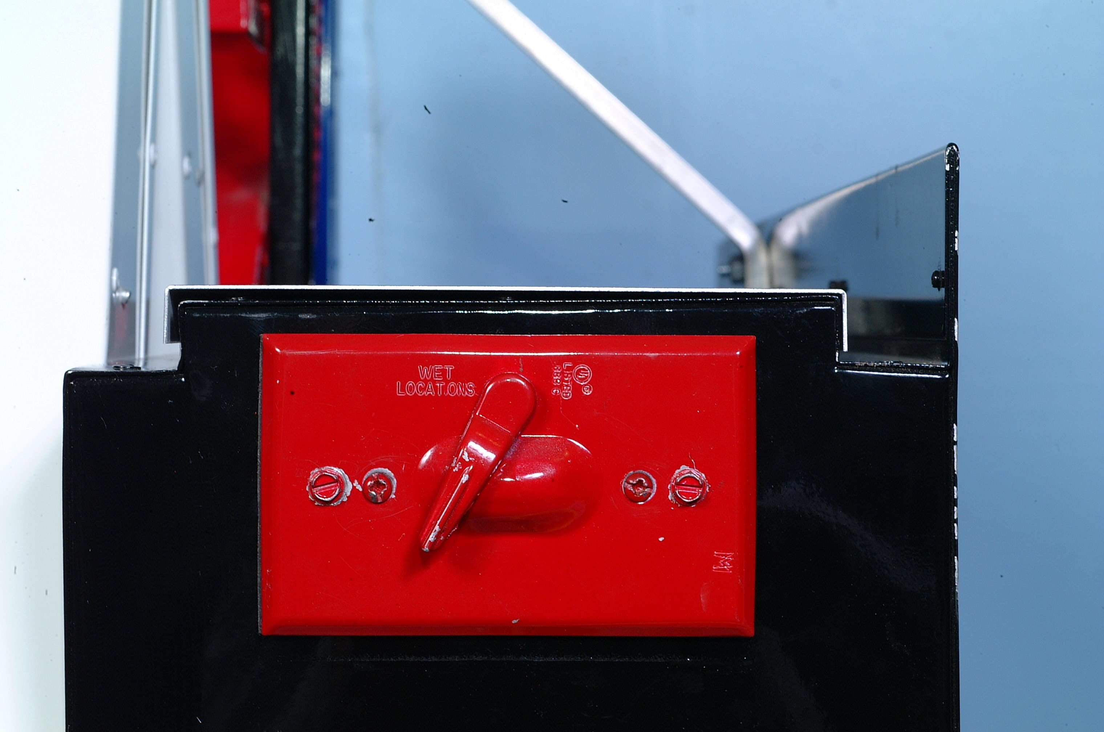

ARTICLE 406 Receptacles, Cord Connectors, and Attachment Plugs (Caps)

406.1 Scope. This article covers the rating, type, and installation of receptacles, cord connectors, and attachment plugs (cord caps).

This section applies to portable cord connected and if you include receptacles in or on you product.

ARTICLE 410 Luminaires (Lighting Fixtures), Lampholders, and Lamps
I. General
410.1 Scope. This article covers luminaires (lighting fixtures), lampholders, pendants, incandescent filament lamps, arc lamps, electric-discharge lamps, the wiring and equipment forming part of such lamps, luminaires (fixtures), and lighting installations.

This section refers to electric discharge lamps when used in area lighting applications commonly referred to as "Cold Cathode". There are some lighting systems, which operate at less than 1000 volts and will be installed in accordance with the articles in this section.
XIV. Special Provisions for Electric-Discharge Lighting Systems of More Than 1000 Volts

410.80 General.

(A) Listing. Electric-discharge lighting systems with an open-circuit voltage exceeding 1000 volts shall be listed and installed in conformance with that listing.

(B) Dwelling Occupancies. Equipment that has an open-circuit voltage exceeding 1000 volts shall not be installed in or on dwelling occupancies.

This section was changed to include the Listing provision. Electric discharge lighting can be installed without secondary-circuit ground-fault protection provided it is Listed and installed as an "Electric Discharge Lighting System, Code Cathode". Further information may be obtained directly from the UL site UL.COM by going to the certifications directory and using IFAY for the search. This is a special category in UL 48 (IFAY) written to accommodate the lighting industry. If this lighting is not listed it would fall under Article 600 and require secondary-circuit-ground-fault protection.

Chapter 6 Special Equipment

ARTICLE 600 Electric Signs and Outline Lighting
I. General

600.1 Scope. This article covers the installation of conductors and equipment for electric signs and outline lighting as defined in Article 100.

FPN: As defined in Article 100, electric signs and outline lighting include
all products and installations utilizing neon tubing, such as signs, decorative
elements, skeleton tubing, or art forms.

This section covers the products we manufacture and install. There is also a definition in Article 100 for outline lighting that will differentiate it from the lighting used and Listed in Article 410.

600.2 Definitions.

Electric-Discharge Lighting. Systems of illumination utilizing fluorescent lamps, high-intensity discharge (HID) lamps, or neon tubing.

Neon Tubing. Electric-discharge tubing manufactured into shapes that form letters, parts of letters, skeleton tubing, outline lighting, other decorative elements, or art forms, and filled with various inert gases.

Sign Body. A portion of a sign that may provide protection from the weather but is not an electrical enclosure.

Skeleton Tubing. Neon tubing that is itself the sign or outline lighting and not attached to an enclosure or sign body.

Definitions specific to our industry have been added here for clarification.

600.3 Listing. Electric signs and outline lighting — fixed, mobile, or portable — shall be listed and installed in conformance with that listing, unless otherwise approved by special permission.



This section is clear about the listing requirement. The exception is to have the local authority having jurisdiction approve the product by special permission. The definition for special permission is: Special Permission. The written consent of the authority having jurisdiction. When asked for written permission most of the inspectors become hesitant when they realize they are accepting the liability for the product.

(A) Field Installed Skeleton Tubing. Field installed skeleton tubing shall not be required to be listed where installed in conformance with this Code.

This section refers to field installed or built in the field product. These products are required to comply with all the sections in the code, which refer to the installation.

(B) Outline Lighting. Outline lighting shall not be required to be listed as a system when it consists of listed luminaires (lighting fixtures) wired in accordance with
Chapter 3.

This section allows Listed fixtures to be used when installed in conformance with the code. The key word is system; in Article 410 they list a system for this use. This allows Listed assemblies to be used when installed per their conditions of acceptability.

Lesson 5 Questions:

1. When an external switch is connected and placed on the raceway of a sign how many purposes can it have?

a. Convenience
b. As the disconnect within site
c. For fire department use
d. All the above

2. How is Article 600 different from the first four Chapters?

- It explains how to engineer a sign
- It can supplement and modify other sections of the code
- It specifies how many signs can go on a building or pole
- All the above

3. When do electric signs require Listing?

- When local zoning has adopted the NEC
- When the State has adopted the NEC
- All the above
The 2002 National Electric Code (NEC) Lesson 6

600.4 Markings.

(A) Signs and Outline Lighting Systems. Signs and outline lighting systems shall be marked with the manufacturer’s name, trademark, or other means of identification; and input voltage and current rating.

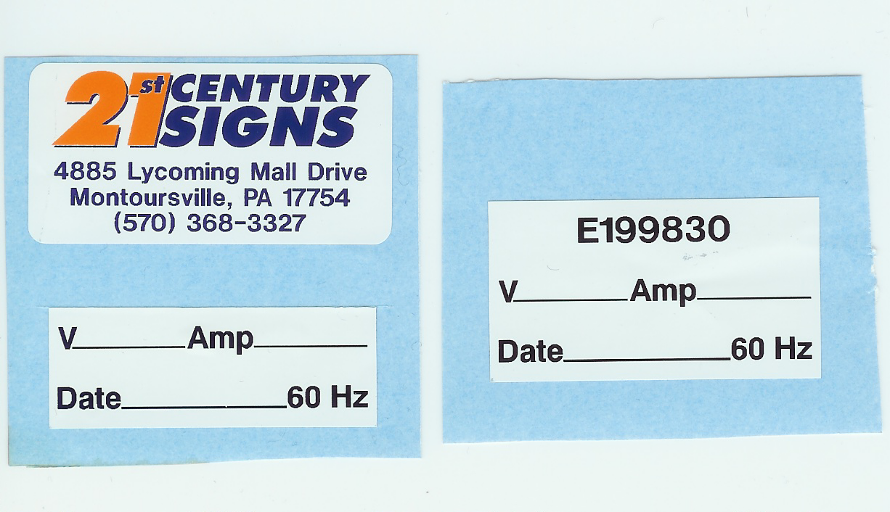
The key phrase is other means of identification, which allows a company to purchase a Listed sign(s) from a wholesale provider having their file number on the sign and allowing the sign company selling the product to display their label on the product. Note if you need to track the manufacturer you must use the file number. As an example, if the number begins with “E” it will be listed by a UL Listed company and you can look up the manufacturer on the UL site under the certifications directory. The example shown was done by the company named on the label.
E 199830 refers to 21st Century Signs and allows another company name on the sign when providing wholesale Listed products
Sign Company Name
(Labels compliments of 21st Century Signs)

(B) With Incandescent Lamp Holders. Signs and outline lighting systems with incandescent lamp holders shall be marked to indicate the maximum allowable wattage of lamps. The markings shall be permanently installed, in letters at least 6 mm (¼ in.) high, and shall be located where visible during relamping.

This section has now survived its second code cycle and I have not seen any proposals for change in the 2005 code. This allows the marking to be visible during relamping and is not required to be visible at all times.

600.5 Branch Circuits.
- Required Branch Circuit. Each commercial building and each commercial occupancy accessible to pedestrians shall be provided with at least one outlet in an accessible location at each entrance to each tenant space for sign or outline lighting system use. The outlet(s) shall be supplied by a branch circuit rated at least 20 amperes that supplies no other load. Service hallways or corridors shall not be considered accessible to pedestrians.

Requiring this circuit has multiple benefits to the industry. First it needs to be in an accessible location, which makes it handy for the sign installation. Second it is required to be a minimum of 20 amperes and we must pay attention to the supply conductors we provide to our sign(s) that they are capable of the amperage. Third the circuit can supply no other load, which means this circuit should have a clean neutral (usually white in color, grounded conductor) and fixture ground (usually green or bare, grounding/bonding conductor) so our new UL 2161 transformers will operate.

- Rating. Branch circuits that supply signs shall be rated as follows.

(1) Incandescent and Fluorescent. Branch circuits that supply signs and outline lighting systems containing incandescent and fluorescent forms of illumination shall be rated not to exceed 20 amperes.

(2) Neon. Branch circuits that supply neon tubing installations shall not be rated in excess of 30 amperes.

The rating section outlines the rating for the type of sign products used and allows a higher rating for neon installations. We must use care when wiring these higher rated (neon) circuits to use wire rated for the amperage.

(C) Wiring Methods. Wiring methods used to supply signs shall comply with 600.5(C)(1), (C)(2), and (C)(3).

(1) Supply. The wiring method used to supply signs and outline lighting systems shall terminate within a sign, an outline lighting system enclosure, a suitable box, or a conduit body.

The supply section outlines how we provide the primary power connections to the sign or outline lighting system. It allows connections to be made within a sign in a suitable raceway; an outline lighting enclosure such as a weatherproof ballast enclosure; a splice box suitable for the application; and a conduit body, which is marked capable of containing a splice.

(2) Enclosures as Pull Boxes. Signs and transformer enclosures shall be permitted to be used as pull or junction boxes for conductors supplying other adjacent signs, outline lighting systems, or floodlights that are part of a sign and shall be permitted to contain both branch and secondary circuit conductors.

This section becomes important when we wish to mix our primary and secondary conductors. This modifies Article 300.3 to allow us to place primary and secondary conductors in our transformer boxes. It also allows us to route other circuits through the sign for other uses such as floodlights on top of the sign.

(3) Metal Poles. Metal poles used to support signs shall be permitted to enclose supply conductors, provided the poles and conductors are installed in accordance with 410.15(B).

Article 410.15 (B) contains the specifications on length of pole, hand hole and grounding terminal requirements as well as referring to Article 300.19 for wire support in a vertical raceway.

600.6 Disconnects. Each sign and outline lighting system, or feeder circuit or branch circuit supplying a sign or outline lighting system, shall be controlled by an externally operable switch or circuit breaker that will open all ungrounded conductors. Signs and outline lighting systems located within fountains shall have the disconnect located in accordance with 680.12.

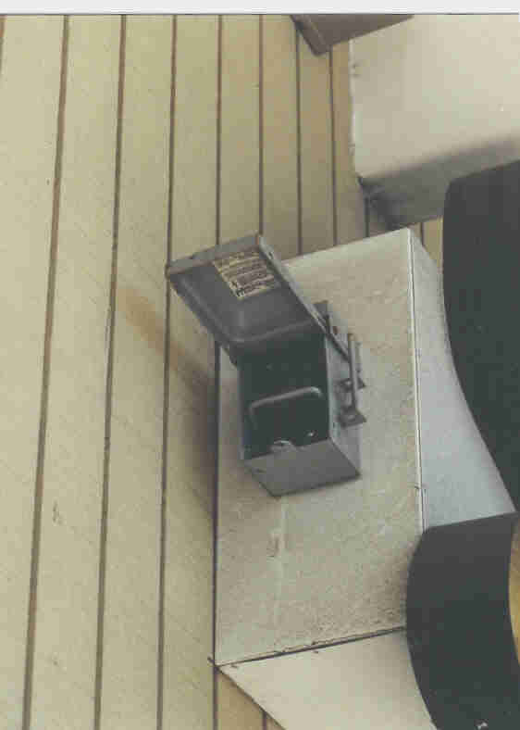
This meets the intent of the code for an externally operable switch. This type of disconnect is easily disconnected by the fire department with a pike pole. (Tool on a handle with a hook on the end)
The section on fountains refer to another section, usually required in locations like Las Vegas, NV

Exception No. 1: A disconnecting means shall not be required for an exit directional sign located within a building.

Exception No. 2: A disconnecting means shall not be required for cord-connected signs with an attachment plug.

600.6 (A) Location.

(1) Within Sight of the Sign. The disconnecting means shall be within sight of the sign or outline lighting system that it controls. Where the disconnecting means is out of the line of sight from any section that may be energized, the disconnecting means shall be capable of being locked in the open position.

When the disconnect is not located in site of the entire sign it must be capably of being locked in the open position. This is a safety issue so while someone is working on the sign someone else does not energized the sign(s) by mistake.

(2) Within Sight of the Controller. The following shall apply for signs or outline lighting systems operated by electronic or electromechanical controllers located external to the sign or outline lighting system:
(1) The disconnecting means shall be permitted to be located within sight of the controller or in the same enclosure with the controller.
(2) The disconnecting means shall disconnect the sign or outline lighting system and the controller from all ungrounded supply conductors.
(3) The disconnecting means shall be designed so that no pole can be operated independently and shall be capable of being locked in the open position.

When the controller is not located in site of the entire sign it must be capably of being locked in the open position. The disconnect must also disconnect all the ungrounded conductors. This is a safety issue so while someone is working on the sign someone else does not energized the sign(s) by mistake.

(B) Control Switch Rating. Switches, flashers, and similar devices controlling transformers and electronic power supplies shall be rated for controlling inductive loads or have a current rating not less than twice the current rating of the transformer.

FPN: See 404.14 for rating of snap switches.

The switch rating is a reminder to use a switch capably of the loads it will encounter during operation including a safety factor.

Lesson 6 Questions:

1. Marking and labels when do they need to be visible?

- During installation and relamping
- When the owners representatives are present
- Upon annual return trips by the zoning officials
- All the above

2. How does the wiring methods in 600.5 (C) (2) modify Chapter 3 wiring methods?

- It will allow primary and secondary conductors in the same raceway
- It will allow flood lights to be mounted to signs and connections run in the raceways
- It will allow primary and secondary wiring in our transformer boxes
- All the above

3. When does the branch or control circuit to a sign need to be lockable?

- When it is convenient for the owner to shut off
- When it is out of site of the sign
- During electrical inspection
- All the above

The 2002 National Electric Code (NEC) Lesson 7

Other good references for this section is my past article on bonding and grounding; reprinted and provided by your association and the Soares book on grounding available from the International Association of Electrical Inspectors.

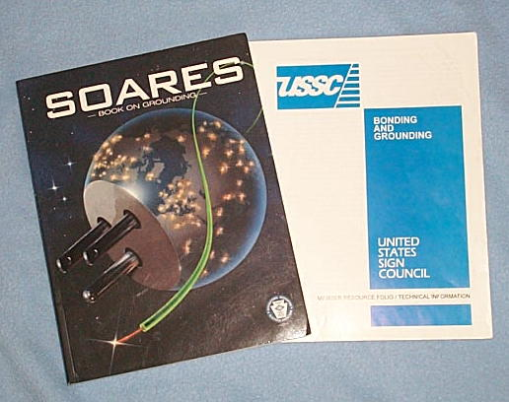

For clarity, in our commentary, we will refer to grounding and bonding in this section, it will reference the equipment bonding conductor, usually bare or green in color.

600.7 Grounding. Signs and metal equipment of outline lighting systems shall be grounded.

This section is crystal clear but becomes the most violated section of the code regarding signs and outline lighting. During my years of investigation I firmly believe that the lack of, or inadequate bonding and grounding is the number one cause of sign fires. The last three words (“shall be grounded”) are the most important in the section since there is no option to not ground any signs or metal equipment.

Generally, the first question that comes to mind is what about plastic conduit or plastic letters? You must remember the high voltage static energy still exists and since the energy was ground referenced at it’s source it will be attracted to any ground which will allow it to return to it’s source. If the sign is operating normally this attraction will be less than if a fault occurs. If a fault occurs the plastic letter or conduit will become part of the fuel source if the fault current finds an opening in the return path, which it must complete with an arc track. Another real concern is if a fault occurs in an area where no ground is present or is in a different ground plane from the secondary circuit fault protected transformer (UL 2161) the transformer will not sense the fault until the fire or fault reaches the area, or ground plane where the transformer is connected.

- Flexible Metal Conduit Length. Listed flexible metal conduit or listed liquidtight flexible metal conduit that encloses the secondary circuit conductor from a transformer or power supply for use with electric discharge tubing shall be permitted as a bonding means if the total accumulative length of the conduit in the secondary circuit does not exceed 30 m (100 ft).

This section modifies Article 250 specifically 250.118 (5)-(6) on total length of flexible metal conduit as a bonding conductor. This was allowed after a field evaluation was completed by UL, Melville in October of 1993. This means the total cumulative length of the installation. This does not change the six foot restriction on the use of any single piece of flexible metal conduit. Article 300 requires flexible metal conduit not exceed six foot in length under any conditions and refers in the sign industry as between a letter, junction box, raceway or any other suitable connection device.

(B) Small Metal Parts. Small metal parts not exceeding 50 mm (2 in.) in any dimension, not likely to be energized, and spaced at least 19 mm (¾ in.) from neon tubing shall not require bonding.

This section was part of the rewrite for clarity from the 1999 code where these sections were all part of one section. It refers to tube supports that the metal base does not require to be bonded, when not part of a larger metal surface.

(C) Nonmetallic Conduit. Where listed nonmetallic conduit is used to enclose the secondary circuit conductor from a transformer or power supply and a bonding conductor is required, the bonding conductor shall be installed separate and remote from the nonmetallic conduit and be spaced at least 38 mm (1½ in.) from the conduit when the circuit is operated at 100 Hz or less or 45 mm (1¾ in.) when the circuit is operated at over 100 Hz.

This section was changed in the 1999 code from allowing the conductor to be run on the outside of the conduit to adding the spacing requirements. The Code Panel in 2002 made this a separate section for clarity. The continued use of the nonmetallic conduit is needed when transformer leads need to be longer than 20 foot in length. Special care is needed to space the ground conductor or ground plane away from the conductor since the nonmetallic conduit can’t restrict the high voltage energy from capacitance coupling to the ground and deteriorating the conduit and wire insulation. Field reports and fire investigation have shown in wet locations this condition can happen rather quickly when moisture is present.
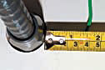

(D) Bonding Conductors. Bonding conductors shall be copper and not smaller than 14 AWG.

The section sets the minimum wire size at #14 AWG. (American Wire Gauge)

(E) Metal Building Parts. Metal parts of a building shall not be permitted as a secondary return conductor or an equipment grounding conductor.

This clarifies that the structural parts of a building are not to be used as part of the wiring system especially the fault return path. In the field we still find people using spouting and coping as the return for some border tubing, clamps into the structural of a building and many other creative ways to start the building on fire.

(F) Signs in Fountains. Signs or outline lighting installed inside a fountain shall have all metal parts and equipment grounding conductors bonded to the equipment grounding conductor for the fountain recirculating system. The bonding connection shall be as near as practicable to the fountain and shall be permitted to be made to metal piping systems that are bonded in accordance with 680.53.

FPN: Refer to 600.32(J) for restrictions on length of high-voltage secondary conductors.

This section was added for the special use in cities like Las Vegas, NV

Lesson 7 Questions:

1. When is it required to bond all dead metal parts to an equipment grounding conductor?

- Only when an electrical inspection is required
- Always
- Only when Listed signs are installed on metal poles
- All the above

2. Can equipment grounding conductors be installed in plastic conduit?

- Yes
- No
- When electrical inspection is required

3. Does Article 250 Grounding and Bonding apply to signs?

- Yes
- When modified and supplemented by article 600
- When mounted on metal poles
- All the above

The 2002 National Electric Code (NEC) Lesson 8

600.8 Enclosures. Live parts other than lamps and neon tubing shall be enclosed.

Exception: A transformer or electronic power supply provided with an integral enclosure, including a primary and secondary circuit splice enclosure, shall not be required to be provided with an additional enclosure.

(A) Strength. Enclosures shall have ample structural strength and rigidity.

(B) Material. Sign and outline lighting system enclosures shall be constructed of metal or shall be listed.

(C) Minimum Thickness of Enclosure Metal. Sheet copper or aluminum shall be at least 0.51 mm (0.020 in.) thick. Sheet steel shall be at least 0.41 mm (0.016 in.) thick.

(D) Protection of Metal. Metal parts of equipment shall be protected from corrosion.

This section refers to how we enclose our live parts, wires, contacts and the like live parts (part intended to be energized). It can be as complicated as a complex raceway for neon channel letters or as simple as a conduit enclosing a GTO wire. The exception refers to the transformers with an integral enclosure.
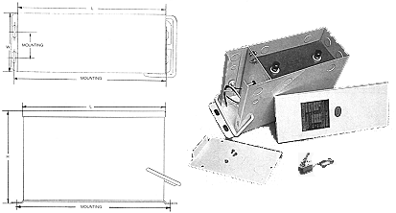

The key statements concern the construction of an enclosure requiring it to be metal or Listed. Metal has proven over time to suitable as an enclosure material. The section includes a minimum for copper and aluminum or steel when used for enclosures. Other materials need to be evaluated and listed for their use, especially with high voltage.

600.9 Location.

(A) Vehicles. Sign or outline lighting system equipment shall be at least 4.3 m (14 ft) above areas accessible to vehicles unless protected from physical damage.

This section just outlines some clearances for signs and outline lighting equipment before additional protection is required.

(B) Pedestrians. Neon tubing, other than dry-location portable signs, accessible to pedestrians shall be protected from physical damage.

This refers to protection of permanently connected neon in show windows, on interior walls, exterior walls and as outline lighting where protection is required. It also allows the dry location portable sign (usually an open or beer sign complete with a cord for connection) to be exempt from additional protection.

(C) Adjacent to Combustible Materials. Signs and outline lighting systems shall be installed so that adjacent combustible materials are not subjected to temperatures in excess of 90°C (194°F).
The spacing between wood or other combustible materials and an incandescent or HID lamp or lampholder shall not be less than 50 mm (2 in.).

Spacing requirements are for the protection of combustibles and minimums for lamps, which create heat.

(D) Wet Location. Signs and outline lighting system equipment for wet location use, other than listed watertight type, shall be weatherproof and have drain holes, as necessary, in accordance with the following:
(1) Drain holes shall not be larger than 13 mm (½ in.) or smaller than 6 mm (¼ in.).
(2) Every low point or isolated section of the equipment shall have at least one drain hole.
(3) Drain holes shall be positioned such that there will be no external obstructions.

This section is a rewrite of the drain hole section to allow for reasonable drain holes in locations where needed and not based on just a number of holes.

600.10 Portable or Mobile Signs.

This section specifically outlines a portable or mobile sign and how they are different from a permanently connected sign.

(A) Support. Portable or mobile signs shall be adequately supported and readily movable without the use of tools.

The support section outlines adequate support but must be removed without the use of tools. This is one of the major differences between a portable or mobile sign and a sign intended to be permanently connected.

(B) Attachment Plug. An attachment plug shall be provided for each portable or mobile sign.

An attachment plug is required making the cord connected sign complete before it leaves the factory.

(C) Wet or Damp Location. Portable or mobile signs in wet or damp locations shall comply with 600.10(C)(1) and (C)(2).

(1) Cords. All cords shall be junior hard service or hard service types as designated in Table 400.4 and have an equipment grounding conductor.

(2) Ground-Fault Circuit Interrupter. Portable or mobile signs shall be provided with factory-installed ground-fault circuit-interrupter protection for personnel. The ground-fault circuit interrupter shall be an integral part of the attachment plug or shall be located in the power-supply cord within 300 mm (12 in.) of the attachment plug.

This section requires the specific type of cords that must be used in wet locations and they must be equipped with ground fault protection.

(D) Dry Location. Portable or mobile signs in dry locations shall meet the following:

(1) Cords shall be SP-2, SPE-2, SPT-2, or heavier, as designated in Table 400.4.
(2) The cord shall not exceed 4.5 m (15 ft) in length.

This section outlines dry location cords and refers to others as specified in the table.

600.21 Ballasts, Transformers, and Electronic Power Supplies.

(A) Accessibility. Ballasts, transformers, and electronic power supplies shall be located where accessible and shall be securely fastened in place.

The section outlines where these parts can be installed and that they shall be securely fastened. The word accessibility is important and as defined by the code: ACCESSIBLE (as applied to equipment): Admitting close approach; not guarded by locked doors, elevation, or other effective means. Some of the places I find transformers would not meet these requirements.

(B) Location. Ballasts, transformers, and electronic power supplies shall be installed as near to the lamps or neon tubing as practicable to keep the secondary conductors as short as possible.

This requirement reminds you to keep the secondary conductors as short as possible.

(C) Wet Location. Ballasts, transformers, and electronic power supplies used in wet locations shall be of the weatherproof type or be of the outdoor type and protected from the weather by placement in a sign body or separate enclosure.

Wet locations have special requirements. Weatherproof and sign bodies will generally make the location inside the box or sign body a damp location. This equipment will need to pass a water exclusion test to qualify.

(D) Working Space. A working space at least 900 mm (3 ft) high, 900 mm (3 ft) wide, by 900 mm (3 ft) deep shall be provided at each ballast, transformer, and electronic power supply or its enclosure where not installed in a sign.

This requirement provides for working space. Once again I do not see a lot of remote equipment meeting this requirement.

(E) Attic and Soffit Locations. Ballasts, transformers, and electronic power supplies shall be permitted to be located in attics and soffits, provided there is an access door at least 900 mm by 600 mm (3 ft by 2 ft) and a passageway of at least 900 mm (3 ft) high by 600 mm (2 ft) wide with a suitable permanent walkway at least 300 mm (12 in.) wide extending from the point of entry to each component.

This section outlines the requirements for access, the access size and outlines a walkway. OSHA requirements are much stronger and more specific for the walkways and passages. In most locations fall protection will be required in these locations.

(F) Suspended Ceilings. Ballasts, transformers, and electronic power supplies shall be permitted to be located above suspended ceilings, provided their enclosures are securely fastened in place and not dependent on the suspended ceiling grid for support. Ballasts, transformers, and electronic power supplies installed in suspended ceilings shall not be connected to the branch circuit by flexible cord.

This section allows for equipment to be installed above the ceilings, without the use of the ceiling structure for attachment. The equipment must be hard wired and not cord connected. Many locations I see have transformers mounted above the ceiling and use window type transformers and plug them in. This installation is not code compliant.

600.22 Ballasts.

(A) Type. Ballasts shall be identified for the use and shall be listed.

(B) Thermal Protection. Ballasts shall be thermally protected.

This section just outlines identified for the use and protected from heating.

Lesson 8 Questions:

1. Do all of our enclosures require to be made of metal?

- Yes
- Enclosures can be made of other materials if Listed for the purpose
- When the enclosures are less than 1000 volts
- All the above

2. Do Field installed section letter signs require field inspection?

- When installed in conformance with their installation instructions
- Yes
- When field connections are required
- All the above

3. Can transformers be installed over a suspended ceiling?

- When securely fastened in place and direct wired
- When cord connected
- When mounted directly to the ceiling frame
- All the above

The 2002 National Electric Code (NEC) Lesson 9

600.23 Transformers and Electronic Power Supplies.

(A) Type. Transformers and electronic power supplies shall be identified for the use and shall be listed.

This section is clear about having the neon transformers and power supplies identified for their use and requiring listing. This is important because not all neon transformers and power supplies will be listed, some will be recognized and will require special installation requirements.

(B) Secondary-Circuit Ground-Fault Protection. Transformers and electronic power supplies other than the following shall have secondary-circuit ground-fault protection:

(1) Transformers with isolated ungrounded secondaries and with a maximum open circuit voltage of 7500 volts or less

(2) Transformers with integral porcelain or glass secondary housing for the neon tubing and requiring no field wiring of the secondary circuit

Secondary-circuit ground-fault protection has been required since 1996 on field-installed products and on listed signs since 1999. The requirements intended to be the quick fix for neon sign fires and quickly became a design and engineering quest for transformer and power supply companies. Once the products started to reach the market other than a few product problems, it became clear that existing installation procedures would need changed and revised for these products to operate. Unfortunately, this just verified the need for better circuit design and installation procedures. Correct bonding and grounding procedures now need to be adhered to for the units to operate effectively for any reasonable amount of time.

(C) Voltage. Secondary-circuit voltage shall not exceed 15,000 volts, nominal, under any load condition. The voltage to ground of any output terminals of the secondary circuit shall not exceed 7500 volts, under any load condition.

This section requires the voltage to ground not exceed 7500 volts to ground because the majority of the products used in the secondary circuits are only rated for 7500 volts.

(D) Rating. Transformers and electronic power supplies shall have a secondary-circuit current rating of not more than 300 mA.

Since most signs and outline lighting circuits are 60ma or less; this section is 300ma for the lighting industry (Cold Cathode) when field-installed under this section of the code and not listed under Article 410. When outline lighting is install per Article 600 secondary-circuit ground-fault will be required on the installation.

(E) Secondary Connections. Secondary circuit outputs shall not be connected in parallel or in series.

This section is clear that secondary circuits of neon transformers and power supplies are not to be connected from one neon transformer secondary to another. (Daisy Chain) The code changed in 1990 and has not allowed this type of wiring to be used in any type of installation.

(F) Marking. A transformer or power supply shall be marked to indicate that it has secondary-circuit ground-fault protection.

Additional markings are required to identify that the neon transformer or power supply has secondary-circuit ground-fault protection. (complies with UL 2161)

II. Field-Installed Skeleton Tubing

This section of the article refers to non-listed field installed skeleton tubing. This section was controversial during the current code cycle (2005). It was the opinion of this author, some electrical inspectors and others that this section should be available to your local electrical inspector to review wiring done behind a building wall for listed channel letter signs. Unfortunately, the TIA (Technical Interim Amendment) and numerous proposals and comments failed due to strong lobbing at the code panel. The panel’s comments related to the requirement that all listed signs are factory assembled and shipped with sub-assemblies and field installed using installation instructions provided by the manufacturer. Next time you get an install to do make sure you get the factory assembled sub assemblies and installation instructions because the electrical inspectors are going to start asking for them before they will inspect the installation.

600.30 Applicability. Part II of this article shall apply only to field-installed skeleton tubing. These requirements are in addition to the requirements of Part I.

The applicability is clear, the current reference only applies to field-installed skeleton tubing.

600.31 Neon Secondary-Circuit Conductors, 1000 Volts or Less, Nominal.

(A) Wiring Method. Conductors shall be installed using any wiring method included in Chapter 3 suitable for the conditions.

(B) Insulation and Size. Conductors shall be insulated, listed for the purpose, and not smaller than 18 AWG.

(C) Number of Conductors in Raceway. The number of conductors in a raceway shall be in accordance with Table 1 of Chapter 9.

(D) Installation. Conductors shall be installed so they are not subject to physical damage.

(E) Protection of Leads. Bushings shall be used to protect wires passing through an opening in metal.

This section refers to the field-installed circuit conductors of 1000 volts or less. These voltages are less critical then the voltages over 1000 volts.

600.32 Neon Secondary Circuit Conductors, Over 1000 Volts, Nominal.

(A) Wiring Methods.

(1) Installation. Conductors shall be installed on insulators, in rigid metal conduit, intermediate metal conduit, rigid nonmetallic conduit, liquidtight flexible nonmetallic conduit, flexible metal conduit, liquidtight flexible metal conduit, electrical metallic tubing, metal enclosures, or other equipment listed for the purpose and shall be installed in accordance with the requirements of Chapter 3.

This section outlines the numerous wiring methods available to install these conductors and reminds us to install them in accordance with Chapter 3 requirements, unless further modified by this section.

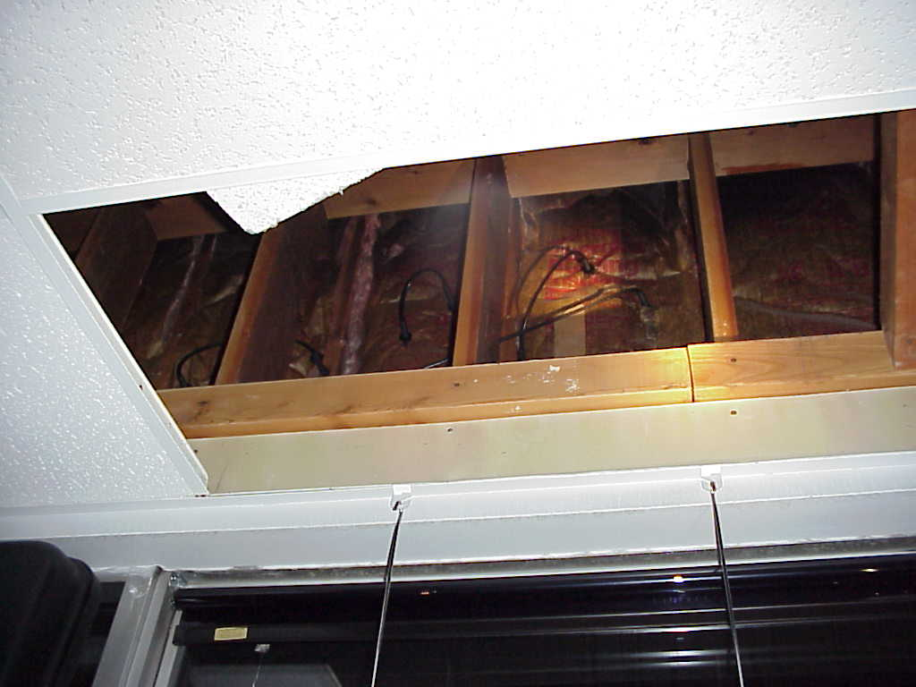
Think any of these wiring methods would meet the code?
Wiring behind the wall on a set of neon channel letters.

(2) Number of Conductors. Conduit or tubing shall contain only one conductor.

This section modifies Chapter 3, in only allowing one conductor in a conduit or tubing regardless of the size or fill requirements of the conduit. This was added to keep from running both high voltage secondaries from a transformer through one conduit.

(3) Size. Conduit or tubing shall be a minimum of metric designator 16 (trade size ½).

This section modifies Chapter 3 by increasing the trade size to ½” to reduce the capacitance coupling dominant in a 3/8” conduit.

(4) Spacing from Ground. Other than at the location of connection to a metal enclosure or sign body, nonmetallic conduit or flexible nonmetallic conduit shall be spaced no less than 38 mm (1½ in.) from grounded or bonded parts when the conduit contains a conductor operating at 100 Hz or less and shall be spaced no less than 45 mm (1¾ in.) from grounded or bonded parts when the conduit contains a conductor operating at more than 100 Hz.

Numerous field failures demonstrated the need to space plastic conduits containing high voltage conductors away from any ground. Plastic conduit will not contain the electrostatic field, present in these circuits and allow the capacitance coupling process to prematurely degrade the wire insulation and the plastic conduit, exposing the high voltage conductor. Once the conduit and wire insulation is degraded and arc to ground can result in a fire.

(5) Metal Building Parts. Metal parts of a building shall not be permitted as a secondary return conductor or an equipment grounding conductor.

This reference is to remind the installer not to use the spouting or fascia to ground or return the secondary conductors. Correct bonding and grounding will create a safe installation.

Lesson 9 Questions:

1. Is secondary-circuit ground fault protection required on all transformers?

  - Yes
  - Only on transformers rated over 1000 volts
  - No
  - Only on transformers rated at 7500 volts to ground

2. Does Part II apply to all electric signs?

- No
- Only for field installed neon signs
- Only to Listed signs
- Yes

3. Shall wiring methods conform to Chapter 3

- Yes
- Unless modified by Article 600
- Primary wiring shall conform to Chapter 3
- All the above

4. When using non-metallic as a raceway for GTO wire which will apply?

  - GTO wire shall be # 14 AWG only
  - Non-metallic conduit must be installed 1 ½ from a ground plane
  - GTO wire shall be installed in sleeving
  - All the above

The 2002 National Electric Code (NEC) Lesson 10

600.32 Neon Secondary Circuit Conductors, Over 1000 Volts, Nominal. (Continued)

(B) Insulation and Size. Conductors shall be insulated, listed as Gas Tube Sign and Ignition Cable Type GTO, rated for 5, 10, or 15 kV, not smaller than 18 AWG, and have a minimum temperature rating of 105°C (221°F).

GTO stands for Gas Tube Oil. The original wire was taken from the oil burner industry. Other uses were spark plug wires and now neon signs. Since GTO cable does not appear anywhere else in the code, we place its requirements in this section to allow its use in neon signs. Other thoughts' concerning the wire is when used in the oil burner and automotive industry the duty cycle in not 100% as required in the sign industry. This may be one of the causes of the premature wire failure.

(C) Installation. Conductors shall be installed so they are not subject to physical damage.

This section accentuates the need to protect the wire from physical damage to extend the life of the wire.

(D) Bends in Conductors. Sharp bends in insulated conductors shall be avoided.

Sharp bends stress the insulation that can become a problem. Especially in high voltage applications.

(E) Spacing. Secondary conductors shall be separated from each other and from all objects other than insulators or neon tubing by a spacing of not less than 38 mm (1½ in.). GTO cable installed in metal conduit or tubing requires no spacing between the cable insulation and the conduit or tubing.

This section was added for two reasons. To explain that two secondary conductors should not be in the same conduit; and to allow one conductor to be placed in a conduit without the required spacing.

(F) Insulators and Bushings. Insulators and bushings for conductors shall be listed for the purpose.

This section is very important to insure the bushings and insulators are Listed for the purpose. This is so important since low voltage bushing and insulators will fail quickly under these conditions.

(G) Conductors in Raceways.

(1) Damp or Wet Locations. In damp or wet locations, the insulation on all conductors shall extend not less than 100 mm (4 in.) beyond the metal conduit or tubing.

Damp and wet locations pose the most extreme conditions and the moisture extends the arcing ability though tracking of the high voltage to ground.

(2) Dry Locations. In dry locations, the insulation on all conductors shall extend not less than 65 mm (2½ in.) beyond the metal conduit or tubing.

The tracking problem is not as much of a problem in dry locations. The next time you are in an area with a neon sign and exposed wire look at all the dust and impurities attracted to the wire.

(H) Between Neon Tubing and Midpoint Return. Conductors shall be permitted to run between the ends of neon tubing or to the secondary circuit midpoint return of transformers or electronic power supplies listed for the purpose and provided with terminals or leads at the midpoint.

(I) Dwelling Occupancies. Equipment having an open circuit voltage exceeding 1000 volts shall not be installed in or on dwelling occupancies.

Dwelling units where children could be present, is the reason neon will not be allowed in dwelling units. Listed portable neon signs, where permitted, can be used in a dwelling unit. Many fraudulent off shore units have flooded our markets and no one including Listing agencies seem concerned.

(J) Length of Secondary Circuit Conductors.

(1) Secondary Conductor to the First Electrode. The length of secondary circuit conductors from a high-voltage terminal or lead of a transformer or electronic power supply to the first neon tube electrode shall not exceed the following:
(1) 6 m (20 ft) where installed in metal conduit or tubing
(2) 15 m (50 ft) where installed in nonmetallic conduit

This section was updated to clarify the first run from the transformer to the first tube needs to be as short as possible and no longer than the above lengths. The higher the voltage and the longer the run increases the capacitance coupling and causes damage to the conductors and eventually the transformer will fault or fail.

(2) Other Secondary Circuit Conductors. All other sections of secondary circuit conductor in a neon tube circuit shall be as short as practicable.

This explains the inner connects and the returns need not adhere to the length restrictions but should be as short as possible. The voltage on the returns should be very low and not add a lot to the capacitance coupling problem of the first runs.

600.41 Neon Tubing.

(A) Design. The length and design of the tubing shall not cause a continuous overcurrent beyond the design loading of the transformer or electronic power supply.

This section was added due to the problems identified with the ANSI footing charts we all use to layout a neon system. Many times the additional resistance of the metal conduit and wiring systems employed inside a building are not taken into account when doing the transformer sizing.

(B) Support. Tubing shall be supported by listed tube supports.

This section was added to insure a good quality tube support. Borosilicate glass used in the original tube supports was fine and field-tested but, when glass started to be imported to reduce cost, more metal was in the glass causing failures especially with high frequency power supplies. Also, other materials were being introduced to the industry and needed to be tested for the purpose.

(C) Spacing. A spacing of not less than 6 mm (¼ in.) shall be maintained between the tubing and the nearest surface, other than its support.

Neon tubing has a small amount of corona even around the tubing and hence needs a minimal spacing.

600.42 Electrode Connections.

(A) Accessibility. Terminals of the electrode shall not be accessible to unqualified persons.

Since we are dealing with high voltage, accessibility would not be prudent. Electrocution is normally not an issue since our current is low but the startle factor can cause fall and other damage.

(B) Electrode Connections. Connections shall be made by use of a connection device, twisting of the wires together, or use of an electrode receptacle. Connections shall be electrically and mechanically secure and shall be in an enclosure listed for the purpose.

Connection types are specified and required to be enclosed in a Listed enclosure.

(C) Support. The neon tubing and conductor shall be supported not more than 150 mm (6 in.) from the electrode connection.

Support is important especially when a tube is broken, that the conductor and connection spacing can be maintained.

(D) Receptacles. Electrode receptacles shall be listed for the purpose.

This specifies receptacles need to be Listed for the purpose. This prevents the substitution of a product not suitable for the use.

(E) Bushings. Where electrodes penetrate an enclosure, bushings listed for the purpose shall be used unless receptacles are provided.

Listed bushings are required to prevent arcing from the electrode shell upon breakage or failure.

(F) Wet Locations. A listed cap shall be used to close the opening between neon tubing and a receptacle where the receptacle penetrates a building. Where a bushing or neon tubing penetrates a building, the opening between neon tubing and the bushing shall be sealed.

Wet locations require prevention of moisture from entering the building wiring system.

(G) Electrode Enclosures. Electrode enclosures shall be listed for the purpose.

This requires the enclosures to be Listed for the purpose.

Lesson 10 Questions:

1. What wiring methods can be used with GTO cable?

- Shall be spaced 1 ½” from other conductors
- Can have zero spacing in a metal conduit
- Shall be installed where they are not subjected to physical damage
- All the above

2. How far can you run a secondary circuit (GTO) conductor in metal conduit from the transformer or power supply to the first tube electrode connection?

- Unlimited as long as it is in sleeving
- 20 feet total
- 40 feet total
- 50 feet total

3. Do electrode receptacles require Listing?

- Only when installed in a wet location
- No
- Yes
- As required by NFPA

ANSWERS: 2002 NEC Lessons

Lesson 1 Answers:
- b
- c
- b
- d

Lesson 2 Answers:
- c
- a
- c

Lesson 3 Answers:
- b
- d
- b

Lesson 4 Answers:
- b
- d
- a

Lesson 5 Answers:
- d
- b
- c

Lesson 6 Answers:
- a
- d
- b

Lesson 7 Answers:
- b
- b
- d

Lesson 8 Answers:
- b
- d
- a

Lesson 9 Answers:
- c
- b
- d
- b

Lesson 10 Answers:
- d
- b
- c

Contact Information for Seminars, Consulting and Neon Sign Fires:

United States Sign Council
211 Radcliffe Street
Bristol, PA 19007
215-785-1922
www.ussc.org

Randall K. Wright

RKW CONSULTING
698 Walnut Street
Montoursville, PA 17754
570-368-1091
www.rkwconsulting.org
e-mail rkw@uplink.net or randy@ussc.org

