Bonding and Grounding a burning issue in the electric and neon sign industry.

While doing a seminar at Atlantic City for Sign World, I was asked. What is the difference between bonding and grounding? What a great question. The major fault, which becomes the ignition source of the fires I investigate concerning neon signs are almost always related to either poor or not adequate bonding or grounding.

Lets start with the definitions as reprinted from the current version of the 2002 National Electric Code.

Bonding (Bonded). The permanent joining of metallic parts to form an electrically conductive path that ensures electrical continuity and the capacity to conduct safely any current likely to be imposed.

Ground. A conducting connection, whether intentional or accidental, between an electrical circuit or equipment and the earth or to some conducting body that serves in place of the earth.

Grounded. Connected to earth or to some conducting body that serves in place of the earth.

Grounded, Effectively. Intentionally connected to earth through a ground connection or connections of sufficiently low impedance and having sufficient current-carrying capacity to prevent the buildup of voltages that may result in undue hazards to connected equipment or to persons.

Ground-Fault. An unintentional, electrically conducting connection between an ungrounded conductor of an electric circuit and the normally non-current-carrying conductors, metallic enclosures, metallic raceways, metallic equipment, or earth.

As we quickly notice, words like "neutral" and "common" are not defined in the code but are used frequently in the electrical industry.

We are going to use the term "Neutral" usually white as our return conductor and only reference it being grounded at the point of delivery for clarity in our system layout.

Lets start at the point where bonding and grounding are the same. This is at the point of delivery (meter location) to the facility or disconnect as it could refer to a sign structure with a meter location. At this location, the neutral, earth ground and bonding are the same and are connected together such as at the ground (neutral bar) and bonded directly to the box (equipment bonding conductor). From this point on they will go their separate ways and have different tasks on controlling the phase or hot wires.

There are numerous configurations of power delivered to the meter location and since these do not seem to be the confusing portion, we shall not discuss them other than to refer to them as the hot wire.

Just for clarity the neutral wire will be current carrying after the first disconnect. This neutral wire (white) will be required to be insulated and isolated from the bonding (green) conductor. The neutral will carry the unbalance between the phase wires.

Back to our real task of trying to explain bonding and grounding. The neutral wire will be run in the electrical system to return the energy after it has preformed its work. Example if you want to make toast you must provide the hot wire with the neutral to provide the heat to darken your toast. This is done with the benefit of an appliance designed to do this task. Along with this appliance, there will be bonding, bonding is a non current carrying direct path to earth ground to accept a unintended fault to ground, so when you drop your knife in the toaster the fault is returned to the fuse panel and your life is spared. At this point, the bond (fault return path) and the neutral (current return path) have different functions.

Now since we have our toast lets talk about signs and their bonding and grounding requirements.

Article 250 of the National Electric Code covers the general requirements for grounding and bonding of electrical installations and electrical utilization equipment (signs). Article 600 will supplement and modified sections specific to Electric Signs and Outline Lighting.

600.7 Grounding.
Signs and metal equipment of outline lighting systems shall be grounded.

This one sentence has so much to say it should fill a complete novel. It is crystal clear that signs and metal equipment shall, not an option, be grounded. Now lets see how that is done. First remember bonding and ground are the same at the original point of delivery and this means we much deliver the neutral usually white to return the voltage when we use it to make electrical utilization equipment work (Transformer) and we are required to bond (green) the equipment in the event a unintended fault occurs to deliver the fault current back to earth ground.

The most common error that occurs is the bonding is not complete and continuous. This generally never creates a problem nor is it discovered until there is a fault.

When a fault occurs, without a direct path back to earth ground, where will the fault current go?

Unfortunately, wherever it wants and wherever it can establish some path via the least line of resistance in its continued hunt for a path back to its earth ground. (Arc Track) Now we all know what happens now, we have a fire if a combustible happens to be in the path or way. The magnitude of the fire depends on many variables.

When was the last time you went out to fix a fluorescent sign and found a wire fire? A couple things could have happened. First we know the neutral was present because it worked at one time. We do not know whether the bonding is complete because the fault current was not returned to the earth ground without incident. Since most of these occurrences happen in a metal raceway further incident generally does not become spectacular. The sign will be out, the customer will call for service and you will correct the problem. At this point you should look to insure the bonding is complete and determine if the wire fire was only caused by the insulation breaking down on the conductor allowing it to contact the bonded metal (fault return path). As you can see, we are dealing with bonding and grounding separately.

Now when the sign was installed and inspected the electrical inspector would pay particular attention to the bonding at that time. Over the years and during the life of the product that bonding could be compromised by some other work done in the facility. If you have a symptom with the sign follow it until you correct the real problem that created the outage. Just fixing the wire fire without determining why it started just increases your liability and insures it will happen again.

Once again for reference, the equipment grounding conductor (bonding) and the neutral are separate here and have separate tasks and functions but are still the same at the original point of delivery. (Meter Location)

The neutral (usually white) is there to make the equipment work and the bond (green) is there to return an untended fault to the earth ground.

The next installation issue is the high voltage used to illuminate neon and argon filled neon tubing. These systems employ voltages up to 15,000 volts and 7500 volts to ground when referenced. These systems create the most potential for failure and the likelihood of unintended fault current. That being said, bonding, bonding, bonding is the most important component in these systems. Installations and inspections need to be focused. In almost every fire I investigate, the lack of adequate bonding is present.

This can happen in numerous ways. In the delivery of secondary power from a transformer to the first and subsequent tubes the bonding must be continuous and be able to provide an uninterrupted return path when a fault occurs. Some of the more common problems I see are the connections in the neon tube circuit are not all bonded continuously back to the transformer box. The transformer is not bolted securely to the box; the bonding wire is not connected or continuous. These seem like little omissions when a transformer is replaced, but could lead to a spectacular fire event.

S I G N
Disconnect
Metal letters
Meter
Earth
Ground
Transformer Box

The above drawing only shows the equipment bonding conductor (Green) diagram.

Every place there is a connection where an unintended fault could occur the bonded (equipment grounding conductor) must be present, continuous and available to return the fault current safely to earth ground. Components used in these types of installations all should have some type of bonding connection. It is your task to make sure they are continuously connected (bonded). The electrical inspector will only be there on the original installations to review your work.


I still see a large number of metal clad electrode receptacles that do not have bonding other than the flexible metal conduit attached to the rear of the receptacle. In some cases these are connected with nonmetallic conduit and no bonding is present anywhere. These parts are supplied with two gaskets to exclude moisture from the building and in doing so insulate themselves from the letter or raceway they are attached to, interrupting the continuous bonding. Still in some locations the rear gasket is discarded or was never present and even though the manufacturers paste warning labels all over these products there is still no provision included with the part to bond it. The usual failure is when the glass insert breaks and the bonding is lost because it either becomes lose or it drops away from the letter or channel. This fault can be caused by failure of the GTO in the metal conduit as it enters the receptacle, or failure of the tubing and without continuous bonding the fault current will hunt and arc track generally causing a fire. These problems are easily corrected by making sure the bonding is complete and continuous.

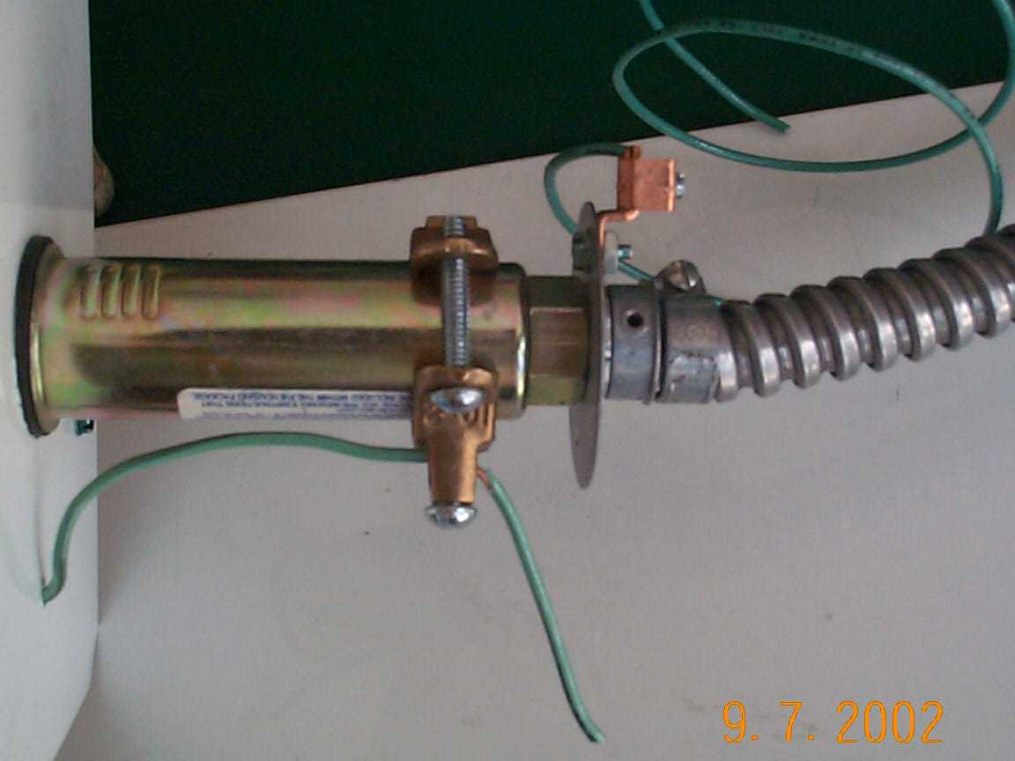

Since April of this year it has become clear that the Authority Having Jurisdiction (AHJ) the local electrical inspector has the responsibility to inspect all primary and secondary wiring of section letter signs and signs shipped in sections even if they have a listing mark. This is a change in interpretation in the industry that if a sign shipped in sections was listed and labeled some thought that it did not need any further inspection of the secondary wiring system shipped to the site with installation instructions. The Listing Agency is clear that any field installed wiring is not part of the Listing.

This change in interpretation other than requiring a TIA Technical Interim Amendment to the 2002 National Electric Code will require some other product changes such as the provisions for bonding in these section letters and on components used for these connections. Since changing a Listed product in the field violates its Listing these additions will need to be done in the factory. This is a good thing for two reasons the bonding connections need to be on the equipment before it leaves the factory, not depend on labels to accomplish it, and we will have another set of eyes, the electrical inspector, looking for the bonding.

We need to say a word about the new secondary-circuit ground-fault transformers and power supplies that we all use today, hopefully. These products are designed with higher limits then the ground-fault around our pool or hot tub because they are designed to stop a fire when a fault occurs. They are not intended as personnel protection. What does that mean; you can still get a shock from some of the units even when on fault. To prevent electrocution was not their purpose and to require that level of protection they, would false trip and become a service nightmare. These units also depend on bonding to sense faults that occur in the system. If the system is not complete, they can't sense the fault. Some will just not operate until the system is complete and bonded (the equipment grounding conductor) is provided, while others will not shut off. Contact for preferred transformer or power supply manufacturer for further details.

Lets put out the fires; it's as easy as bonding. I hope this explanation provides some clarity on Bonding and Grounding.

Comments and questions rkw@uplink.net
Special thanks to Al Zimmerman and Mark Seitz for pre press comments and NeonInstallationguide for photos.

